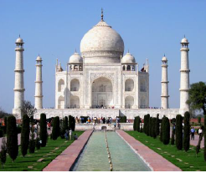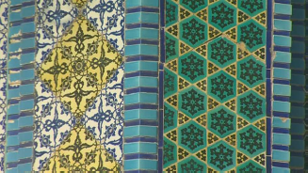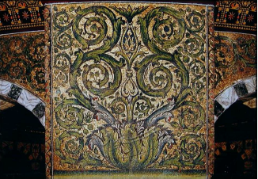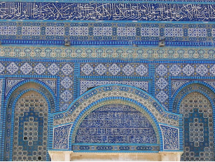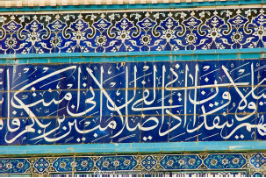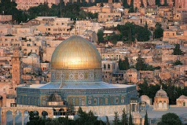

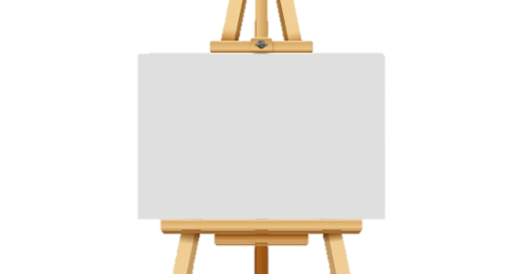

**Art Knowledge Organiser**

**Unit of Work: Islamic Art**

**Year Group: 5 Term: Summer A**

**Architecture:**

. The Dome of the Rock (Jerusalem).

. The Taj Mahal (Agra, India).

**Key Vocabulary:**

Islamic art/architecture – Art or architecture which relates to the religion of Islam or the Islamic world.

Mosque – A place of worship for Muslims.

Minaret – A thin tower, usually part of a mosque, from which a person calls Muslims to prayer.

Dome – The hollow, upper half of a sphere, often used in Islamic architecture.

Calligraphy – Decorative handwriting.

Geometric patterns – A pattern made out of geometric shapes such as triangles, squares, circles.

Vegetal patterns – A pattern made out of shapes and lines which represent plants.

Figural – Art work showing humans or animals.

Key figures: