Activities for online intervention support

Reading  can have paired book with adult to support. Ask questions on text. Listen for words they may struggle with and write on a white board to go over again | Spelling tasks  give definition – child has to guess word | Syllable game  Clap out the syllables in the word - swap
Hangman  guess your spelling word | Draw your word  teacher guesses which word it is | Pyramid words  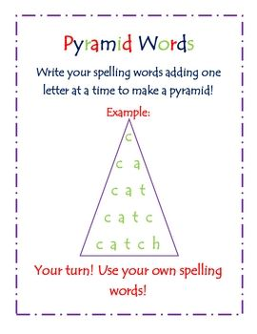
Rainbow writing – write on page in different colour pens – use multiple pens to write letter or word  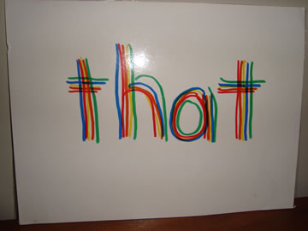 | SPEECH AND LANGUAGE  Would You Rather:  Given two equally preposterous choices, kids must choose between the options. | SPEECH AND LANGUAGE  First Letter, Last Letter  This is a fun word game that helps reinforce spelling and vocabulary skills. Choose a category—for instance, animals. The child will name an animal. For example, dog. The teacher must name an animal that starts with the last letter of dog—like giraffe. The child must name an animal that begins with the last letter of giraffe and so on.
LEGO Challenge  Instruct student to build something overnight and bring it to your meeting the next day. Can be a word or a creation. Student shares.  Can they follow instruction to build something simple together | Drawing on Your Head  Name an object, for example, a tree or a lion. Student must put their whiteboard (or a piece of paper on top of a book) on top of their head and draw the named object. When they think they are done, they take their drawings off their head and show them to the teacher. | SPEECH AND LANGUAGE  Story Chain  Start a story with an engaging hook. For instance, “One day I was walking through a shady forest. I thought I was alone, but all of a sudden…” Have student tell the next portion of the story. Teacher then continues the story (just a line or two) and back to the pupil etc
Memory  Prepare a board with random items such as a brush, a pencil, a spool of thread, etc. Tell pupil you are going to give them 20 (or however many you think is appropriate) seconds to memorise the items they see. Student cannot write down a list of the items or take a screenshot; they must memorise by sight only. Move the board out of sight and take one item away. Show the board on screen again and see if they can name the missing item. | Mystery Sound  This is a fun activity that tests students’ power of perception. With your hands out of sight from the camera, make a sound with something. For instance, crumple up a piece of paper, strike a spoon on the rim of a glass, or snap your fingers. Let students take turns guessing what they hear. | SPEECH AND LANGUAGE  5 Second Rule  This fun game give student 5 seconds to name 3 things that fit into a particular category, such as “Name 3 fiction books” or “Name 3 insects.” Sounds easy, but five seconds isn’t much time!
I spy | Letter change  Write short word down. Can we change one letter or sound to make another word?  Cat – bat – hat  Flag – bag – hag  Book – look- cook | Number bonds  Teacher to write a number on board – child to say what it’s partner to 10 is
Read aloud  Make yourself take up the full screen so the student can see the pictures easily. Note- the words will appear backwards on your side but rest assured they are not backwards from your students’ screens. Ask questions on what you’ve read. Pick out some words from text to discuss | Scavenger hunt  Announce a household item that the student needs to find. Give a goal time limit to find their item and return to show.  Slipper  TV Remote  Keys  Piece of Fruit  Something red  Something soft  Something round  Pair of glasses  Something starting with B  Something that sound the same as cat | Mystery Bag  It’s great for practicing inferencing skills! Place a “mystery item” in a paper bag and give the class clues as to what it might be. Student guesses what the mystery item is. This can also be done with a student giving the clues and having the mystery item at their house.  Can be used in Maths for example I have a Number or a shape in here. Encourages qus such as ‘Is it higher than 5…?’
Rhyming  Show a picture card and pupil says other words that rhyme with the picture (a picture of a cat could rhyme with bat or mat). | Number Rhymes  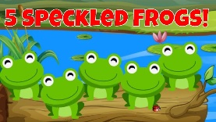  such as Five Green and Speckled Frogs, can be used to teach subtraction, introduce describing words (five, green, speckled), practice ordinal numbers, identify verbs (eating, jumped), explore vocabulary, isolate beginning sounds, locate rhyming pairs, or clap syllables. | Which doesn’t belong?  Items all with same sounds/first letter sound etc  Pupil needs to find which one is different to others

