The Ages |  | Changes over time… In a nutshell
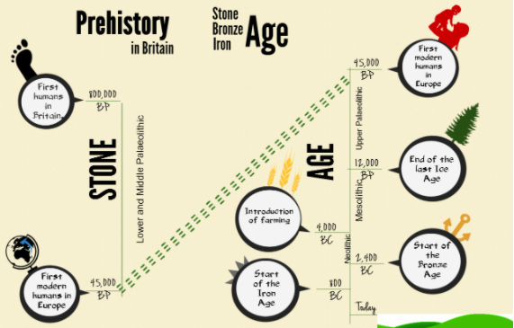 |  | The Ice Age –  During the Ice Age almost all of Britain was covered by ice. There were no people only animals.  Then the ice began to melt  The Stone Age –  Stone age people made tools out of stone, wood or bone. They survived by hunting before learning to farm.  People began to discover  The Bronze Age –  People found out how to make bronze, which was much stronger.  People discovered more  The Iron Age –  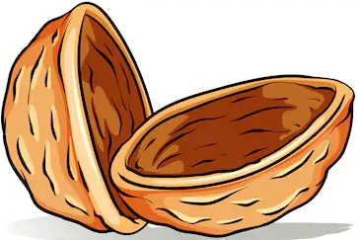  People started to make a metal called Iron, during this time the Celts lived in Britain and they left lots of things behind for us to explore.
Key Dates
10,000 BC- The end of the Ice Age- people started to rein habit Britain.

54 BC- The Roman Invasion- beginning of written records.

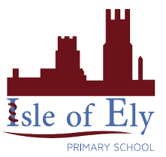
Knowledge Organiser
Autumn Term 1
The Ages – History
Vocabulary
Prehistoric | The period before written records were made.
Archaeology | The study of human history and prehistory through the excavation of sites and the analysis of artefacts and other physical remains
Woolly mammoth | An animal which has a long shaggy coat, small ears and a thick layer of fat.
Glacier | A slowly moving mass or river of ice formed by the accumulation and compaction of snow.
Nomadic | Living the life of nomad.
Stonehenge | A prehistoric monument in Wiltshire, England.
Hoard | A stock or store of money or valued objects, typically one that is secret or carefully guarded.
Celt | A member of a group of people who lived in Ancient Britain.
Iron | A strong, hard magnetic silvery grey metal.
Bronze | A yellowish brown alloy of copper.

