Knowledge Organiser
Network of Support
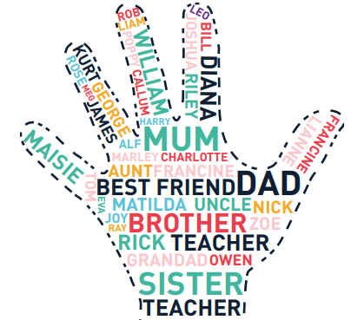
Year 2 - Autumn Term B
Vocabulary
Anti-bullying | Things that we can do or say to prevent bullying from happening.
Assertive Behaviour | Talking or acting with others in a direct and honest manner without intentionally hurting anyone's feelings.
Body Language | When people communicate how they are feeling through facial expressions or movements of their body
Bullying | Bullying is the repetitive, intentional hurting of one person or group by another person or group
Bystander | A bystander is a witness who sees or knows about bullying happening to someone else, but often does nothing to help.
Cyber Bullying | Bullying which happens using a digital device such as a computer and/or online.
Emotions | How we feel about what we are experiencing.
Network of support | A group of trusted adults whom you can speak to when you need support.
Restore | To make something better again, this may be a restorative conversation if someone has been unkind to you.
PSHE – Anti-Bullying

How do you think bullying makes people feel?
Feelings Emotions

