Knowledge Organiser
Key Facts
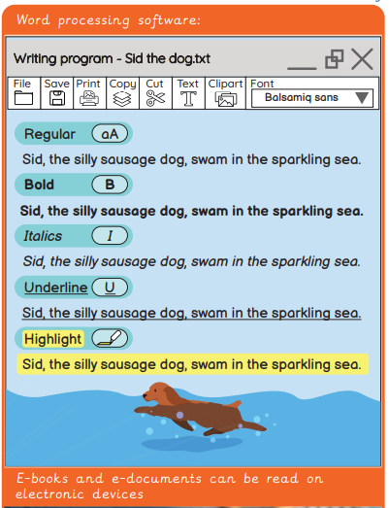
Year 2 - Autumn Term B
Key Facts
Vocabulary
Copyright | The law that protects other peoples work from being copied or used without permission.
Delete (text) | A button on the keyboard that deletes text.
Import | To place another file into a document, such as an image.
Keyboard | An input device made up of buttons that create letters, numbers, and symbols, as well as perform other functions.
Paste (text) | To insert copied or cut text.
Redo | A step forward to the next edit
Space bar | A button on the keyboard to insert room between letters
Touch Typing | Using the keyboard with all your fingers, without looking at the letters on the keys.
Word Processing | A program used for creating text documents on a computer.
Computing – Word Processing

