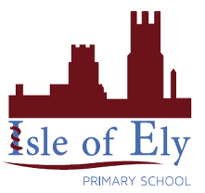
Knowledge Organiser
Year 2 – Autumn Term - B
Vocabulary
Egypt | A country in Africa.
Africa | A continent on Earth.  A continent is a large solid area of land. Earth has seven continents.
The River Nile | A river that flows through Egypt.  Ancient Egyptians lived near the Nile.
Archaeologist | A person who studies human history by the excavation (digging up!) of sites and by analysing what they find.
Artifact | These items they find are called artifacts.
Hieroglyphics | A system of writing used by Ancient Egyptians.
The Rosetta Stone | The Rosetta Stone helped people to understand hieroglyphics.
Pharaoh | A ruler/leader in Ancient Egyptian times.
History – Ancient Egypt

