Knowledge Organiser
Year 2 - Autumn Term B
Vocabulary
Adaptation | Many plants and animals have adapted so that they can survive in a particular habitat.
Alive | A plant or animal that is alive moves, grows and reproduces.
Consumer | A consumer is a plant or animal that eats another plant or animal.
Dead | Something that was living but is no longer alive
Food chain | A food chain is a diagram which shows us how animals are linked by what they eat and what eats them.
Habitat | A place where plants or animals live
Microhabitat | A very small part of a bigger habitat, e.g. woodlice living under stones in a garden.
Producer | Plants are called producers because they produce their own food. Food chains start with a producer.
Science – Living things in their environment

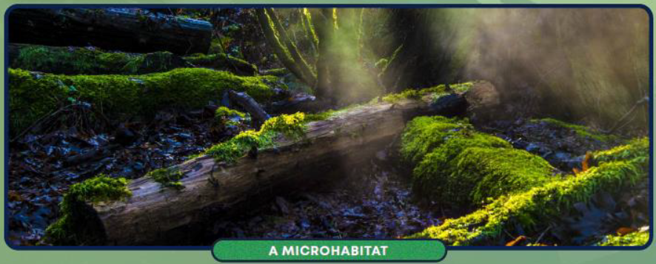

Can you think of any other microhabitats?

