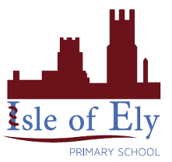
Knowledge Organiser
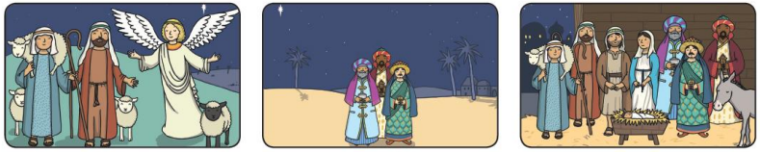
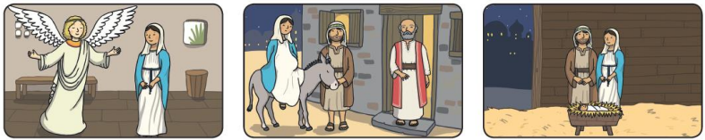
Year 2 - Autumn Term B
Vocabulary
Nativity | The birth of Jesus.
miracle | An event that is surprising and unexpected. Christians believe that the birth of Jesus was a miracle because God sent Jesus to Mary.
Christmas | The Christian celebration that celebrates the birth of Jesus.
celebrate | Doing something enjoyable because of an occasion. We will learn how Christians celebrate Christmas in different countries around the world.
Advent | Advent means “coming”. It starts four Sundays before Christmas. Christians prepare to celebrate Jesus’s birth in this time.
RE – Christianity: The Importance of Christmas

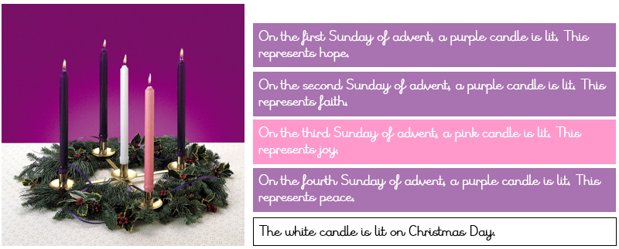

The Nativity Scene

The Advent Wreath

