Joan Miro |  | Different types of lines
A Spanish painter, sculptor and ceramicist born in Barcelona. He was considered an abstract artist. 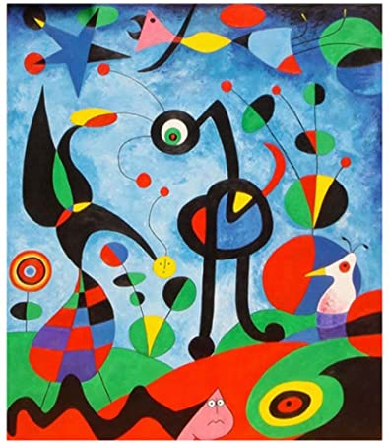 |  | There are many different types of lines that we can create in art, here are a few –  Straight lines  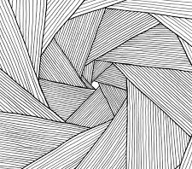  Zig-Zag lines  Curved lines  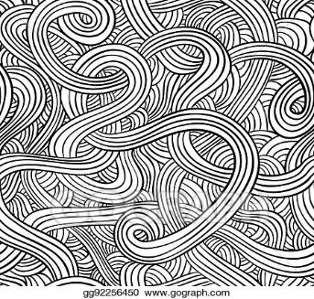  Which is your favourite?
Rembrandt van Rijn
A dutch draughtsman, painter and printmaker – Saskia in a straw hat 1633.
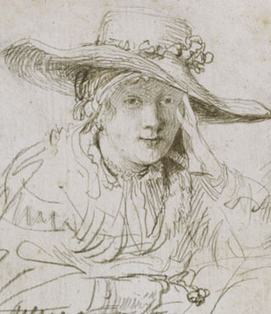
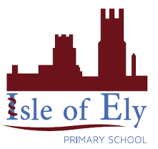
Knowledge Organiser
Autumn Term 2
Art – Elements of Art: Line
Vocabulary
Line | A long, narrow mark or band.
Straight | Properly positioned so as to be level, upright or symmetrical.
Thick | Something that is large in width.
Thin | A line which is small in width.
Zigzag | A line or course having abrupt alternate right and left turns.
Viewfinder | A device which shows the field or view focus.
Curved | Having the form of a curve or bend.
Interpretation | A stylistic representation of creative work.

