Fruit |  | Where does our food come from?
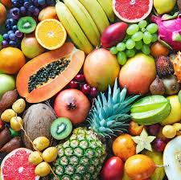  A plant or part of a plant used as food, it is a seed bearing structure that develops from a flowering plant. |  | 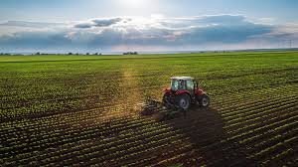  Lots of our food comes from farms and the land, we can eat this food and we use it to make recipes. The food is farmed and then we often buy it from shops. We get our food from all over the world!  https://www.youtube.com/watch?v=9Opt06QF9WY
Vegetables |  | How to make a smoothie!
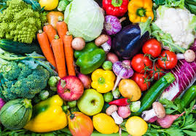  A plant or part of a plant used as food, they are plant parts such as roots, leaves or stems |  | Ingredients:  - Handful of strawberries  - 1 Banana  - 2 peaches  - 1 cup of orange juice  Equipment:  - Blender  Instrutions:  - Put the strawberries, banans and peaches in the blender.  - Blend the fruit  - Add the orange juice.  - Pour in to a cup.
Knowledge Organiser
Autumn Term 2
DT – Food: Fruit and Vegetable Smoothie
Vocabulary
Bacteria | A member of a large group of unicellular microorganisms which can cause disease.
Design | A plan or drawing produced to show the look and function of something before it is made.
Equipment | The necessary items for a particular purpose.
Cut | Dividing things in to pieces with a knife or other share implement.
Practical | The actual doing of something rather than the idea.
Recipe | A set of instructions for preparing a particular dish.
Cooking | The practice or skill of preparing food by combining, mixing and heating.
Ingredient | Any of the foods or substances that combined to make a dish.

