1. Listening |  | 2. Musical Activities
Can you find the pulse as you are listening to the music:  Can you dance, get funky or find the groove?  What instruments and voices can you hear?  Singers, keyboards, bass, guitar, percussion, trumpets or a saxophone? |  | Find the pulse  - March and find the pulse  - Be a money finding the pulse  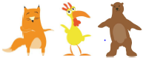  - Be an elephant finding the pulse  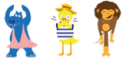  Clap the Rhythms  - Copy and clap back rhythms  - Clap the rhythm of your name  - Clap the rhythm of your favorite colour  - Make up your own rhythm  Listen to the pitch  - Is it high or is it low?
3. Perform and Share
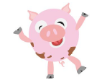
Year 1 will be learning a class performance.

I wonder if they will add any funky moves.

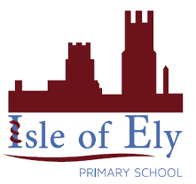
Knowledge Organiser
Autumn Term 2
Music – Rhythm in the Way We Walk and Banana Rap
Vocabulary
Reggae | A music genre that originated in Jamaica in the late 1960s.
Appraise | Children's expression of feelings about and opinions on pieces of music.
Pulse | A steady beat like a ticking clock or your heartbeat.
Style | Characteristic manner of presentation of musical elements.
Structure | The order that different parts of the song are played in.
Rhythm | The placement of sounds in time.
Hip - Hop | Also known as rap music, is a genre of popular music developed in the United States.
Influential | People are influenced by music they listen to
Pitch | High and low sounds

