Shadows |  | Sources of light
Why are some shadows darker than others?  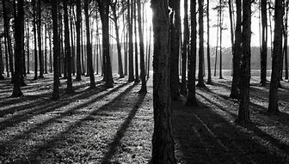  Can transparent, translucent and opaque objects all make shadows?  What does dark mean? |  | There are many different sources of light. Here are a few examples:  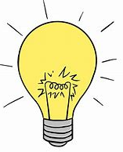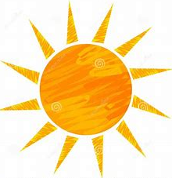  Which are the brightest? Which are best for lighting up a room? How do we stay safe around candles?
Sound and vibration
There are many different objects that can make noise. Sound is created when an object is made to vibrate.
Music is the vibrations made when you play an instrument. When you make sounds using certain instruments you can see the vibrations.
We can change the sounds we make with instruments.
Knowledge Organiser
Autumn Term 2
Science – Everyday Materials
Vocabulary
illuminate | To make something bright by shining a light on it
light source | Something that makes light
reflect | To throw back light
opaque | Something you cannot see through
translucent | Allowing some light through. Semi-transparent
transparent | Allowing light through so that objects behind can be seen clearly
shadow | A dark shape produced when light is blocked
sound | Vibrations that travel through the air and can be heard using your ears
source of sound | Where the sound comes from
vibration | A quick, shaking or quivering movement

