How will we make our clay sculptures? |  | What will we use to create our sculptures?
Mould  Shape  Utensils  Dry  Twist  Ball  Pinch  Roll |  | 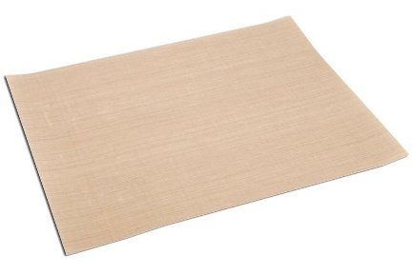  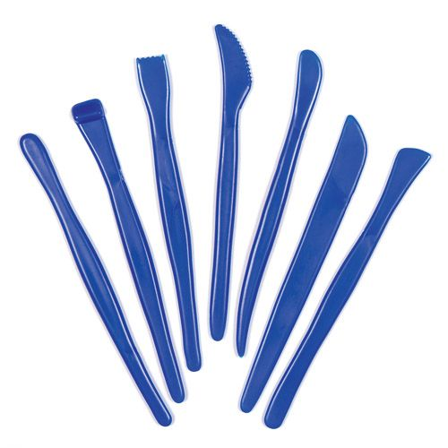  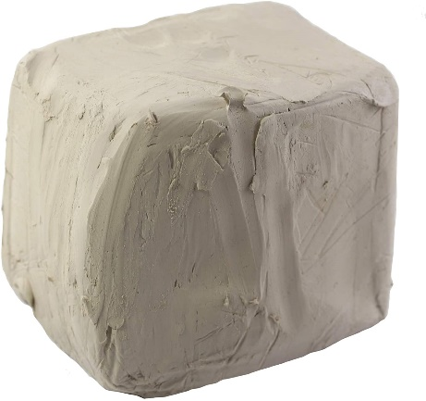  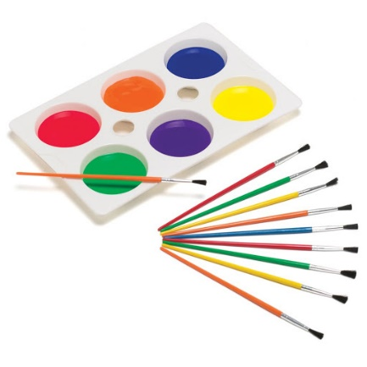
Finishing and Evaluating our sculptures
- Using our knowledge of colour (primary, secondary, shades and tints) we can add colours to our sculptures
- By asking ourselves what went well, how we could improve, and what lines, colours and techniques we used we can evaluate our work
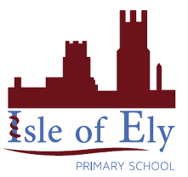
Knowledge Organiser
Spring Term 2
Art – Sculpture
Vocabulary
Sculpture | Carved, cast or shaped forms of art
Mould | To form an object out of a suitable material
Shape | Make something into a particular shape or form
Evaluate | Reviewing and judging a piece of work
Improve | To make something better
Primary colours | A group of colours from which all other colours can be mixed
Secondary colours | Colours made by mixing two primary colours
Tints | Made by mixing white with a colour to make it lighter
Shades | Made by mixing black with a colour to make it darker
Lines | Examples include straight, zig zag and curved

