Windmills
There are lots of different types of windmill around Britain. Have you seen any of these before?
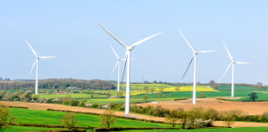

The Three Main Parts of a Windmill
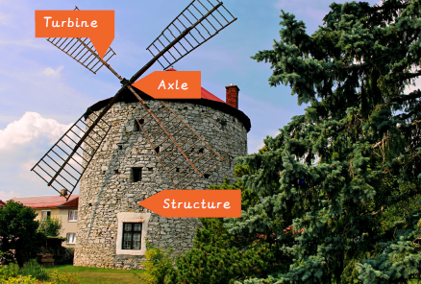
The Mouse
Remember to think about what the mouse will like. He will be living in the windmill and will need to be happy.
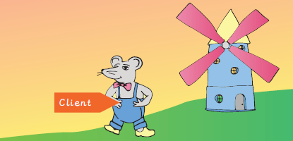

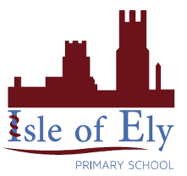
Knowledge Organiser Spring Term 2
DT – Taking Care of the Earth
Vocabulary
Client | The person who you are designing something for.
Design | To make, draw or write plans for something.
Design Criteria | A set of rules to help you with your ideas and test the success of them.
Evaluation | When you look at the good and bad points about something, then think about how you could improve it.
Net | A flat 2D shape, that become a 3D shape once assembled.
Stable | Object does not easily topple over.
Strong | It doesn’t break easily.
Structure | Something that has been made and put together. For example a building, bridge, chair or table.
Test | To find out whether something words as it should.
Weak | It breaks easily.
Windmill | A structure with sails that are moved by wind.
Windmill axle | The point from which the turbine or sails move.
Windmill structure | The part that makes the windmill stand up.
Windmill turbine | The parts that move in the wind.

