Flags of the UK |  | Weather of the UK
The Union Flag is made up of parts of the flags from England, Scotland and Ireland.  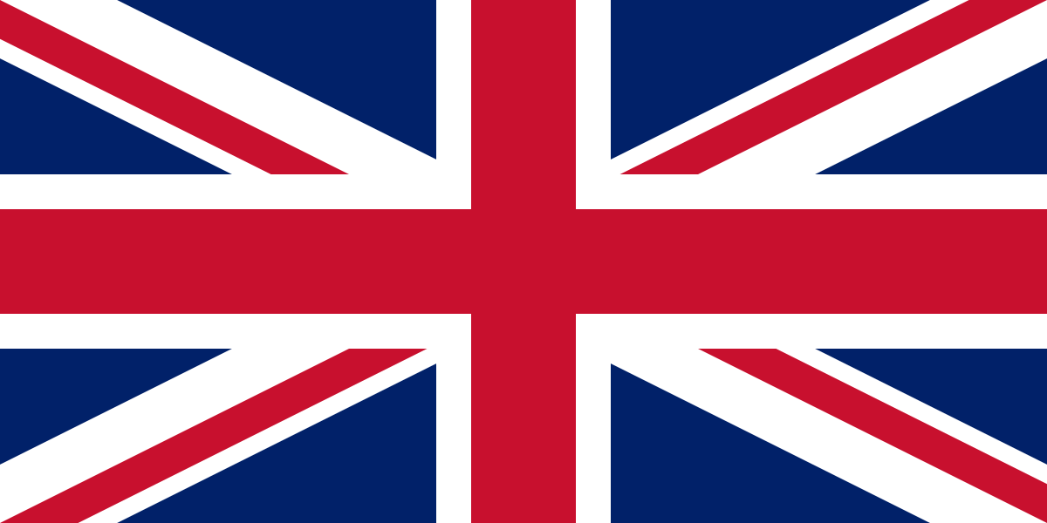  The flags of the UK –  England, Scotland, Wales.  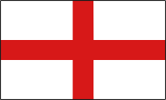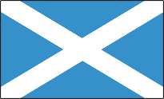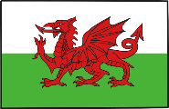  Northern Ireland has no flag of its own. |  | Weather is precipitation (rainfall), temperature and wind speed.  Here is the average weather forecast for the UK.  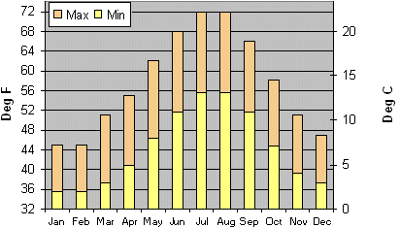
Physical Geography of the UK |  | The Four Seasons
Some facts about the UK’s physical geography  - Scotland and Wales have lots mountainous areas.  - England is mostly rolling hills, with some flat areas such as the Fens.  - Northern Ireland is part of a small island so you need to cross the sea to get to it.  - It is colder and wetter in Scotland than England. |  | The UK is temperate which means the weather changes throughout the year.  The four seasons are Spring, Summer, Autumn and Winter.  What do you know about the different seasons?
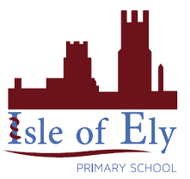
Knowledge Organiser
Spring Term 2
Geography – The UK Geography and Climate
Vocabulary
Union flag | The national flag of the United Kingdom.
Physical geography | Natural features of a place.
Mountains | A natural elevation of the Earth’s surface rising from the surrounding level.
Temperature | A degree of hotness or coldness measured on a definite scale.
Island | A body of land surrounded by water.
Season | Each of the four divisions of the year – spring, summer, autumn and winter.
United Kingdom | A country within Europe which is made up of 4 countries – England, Wales, Northern Ireland and Scotland.

