The Baroque Style |  | The Bhangra Style
Baroque music uses strings and sometimes trumpet, oboe or bassoon.  Listen to ‘Let the Bright a Seraphim’ by Handel.  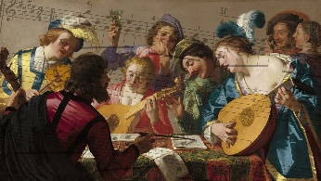  What instruments can you hear?  Can you move in time to the beat?  Can you create a beat to the music? |  | Bhangra music combines traditional Indian music with pop music.  Listen to ‘Jai Ho’ by A.R. Rahman.  Can you find the pulse?  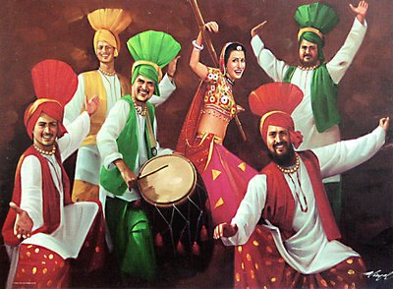
The Latin Style |  | The Folk Style
Latin music is from Latin America and is a mixture of styles (Spanish, African and Latin American). It is upbeat and energetic.  Listen to ‘Livin La Vida Loca’ by Ricky Martin.  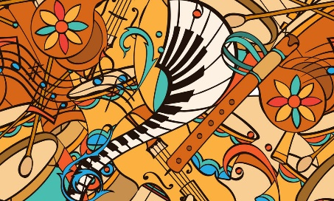 |  | Folk music comes from many different countries. It passes down songs or tunes over many years without writing it down.  Listen & appraise ‘Lord of the Dance’ by Ronan Hardiman  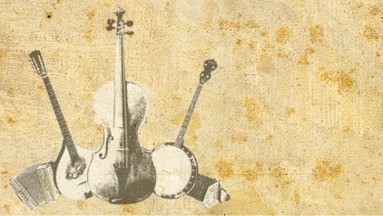  Can you clap rhythms?
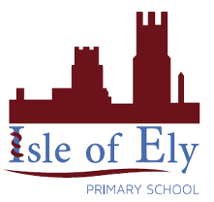
Knowledge Organiser
Spring Term 2
Music – In the Groove
Vocabulary
Blues | Blues is an African-American music that traverses a wide range of emotions and musical styles.
Pulse | A steady beat.
Baroque | A style of European music.
Soprano | The highest singing voice.
Glockenspiel | A musical percussion instrument with metal pieces.
Rhythm | A repeated pattern of sound.
Bhangra | A style of combining Punjabi fold and Western pop.
Folk | A style which has an unknown author and is transmitted through generations.
Compose | Process of creating a piece of music.
Funk | A style that originated in the mid 60’s.

