Guru Nanak |  | Gurdwara
Guru Nanak is considered the first Sikh Guru.  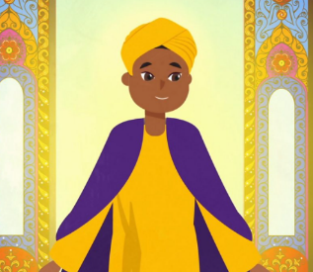  Sikhism is still based on his teachings and those of the nine Sikh Gurus who followed him. |  | 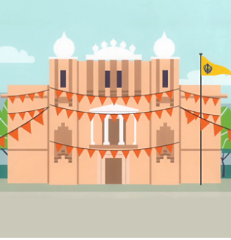  The Sikh place of worship is called a Gurdwara which means 'Gateway to the Guru'. A Gurdwara is any building where the Guru Granth Sahib is kept.  In the UK, Sikhs usually go to the Gurdwara on Sundays. During the services they listen to teachings based on the Guru Granth Sahib. They also chant and say prayers from the gurus. These are called Keertan.  .
Guru Granth Sahib
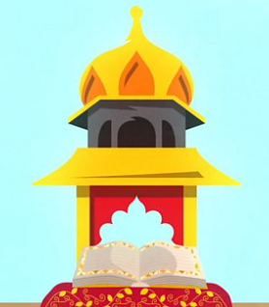
The Sikh holy book is called the Guru Granth Sahib.
Knowledge Organiser Spring Term 2
RE – Sikhism and Beliefs
Vocabulary
Sikhism | Sikhism was founded by Guru Nanak around 500 years ago in a place called the Punjab. This is an area which spans part of India and Pakistan in South Asia today.
Guru Nanak | Guru Nanak is the founder of Sikhism. Guru means ‘Teacher’. Sikhism is still based on his teachings and those of the nine Sikh Gurus who followed him.
KESH | Uncut hair as a mark of holiness and submission to God's will
Guru Granth Sahib | The Sikh holy book is called the Guru Granth Sahib. The tenth Guru, Guru Gobind Singh, said that after him there would be no other living gurus. Instead, Sikhs could look at their holy book for guidance. This is why Sikhs call their holy book a Guru.
Gurdwara | The Sikh place of worship is called a Gurdwara which means 'Gateway to the Guru'. A Gurdwara is any building where the Guru Granth Sahib is kept.
Meditation | Sikh meditation is a practice which seeks ego-transcendence through a gradual process of realizing and immersing into the sacredness of one's self and thus Existence
Honesty | Telling the truth and being honest are important. So are living an honest life and making sure injustice in the world is dealt with.
Humanity | Sikhs believe in the oneness of humanity. This is the belief that all humans are equal because they were created by Waheguru

