The symbol for recycling |  | Oil – can be used to make petrol that we use in cars, it is found deep in the ground.  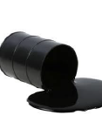  Wind – is a renewable resource. It can be used to turn turbines to make electricity.  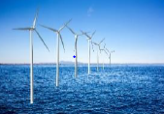  Water – is a renewable resource. Fresh water, come from skies, moves into streams, rivers, lakes and groundwater.  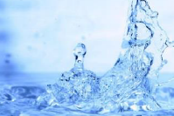
Natural Resources
Coal – A hard, black rock which can be burned, it is found deep in the ground.

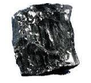
Knowledge Organiser Spring Term 2
Science – Taking Care of the Earth
Vocabulary
Natural Resources | Materials we can use that are from nature, e.g. we can use wood from trees to make furniture.
Manufactured Resources | Materials we can use that people make, e.g. plastic.
Renewable Resource | A resource that doesn’t run out, e.g. wind energy.
Non-renewable Resource | A resource that will run out if we use it all, e.g. coal.
Pollution | A substance that is harmful to the environment, e.g. spilling oil into the sea.
Environment | The natural world around us.
Recycle | To use something again, sometimes for a different purpose.
Conserve | To protect something from harm or destruction.

