Content |  | Process
Key Questions –  - What is the artwork about?  - Have any aspects been exaggerated?  - Do you think there are any hidden meanings?  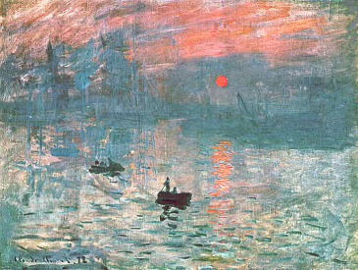 |  | Key Questions -  - How was the work made?  - What was it made with?  - Is it more than one tool?  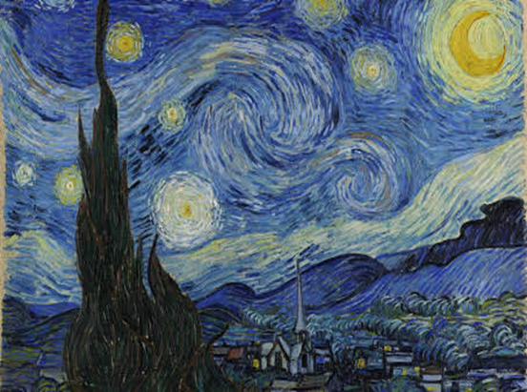
Form |  | Mood
Key Questions –  - How has the artwork been arranged?  - What colours can you see?  - What lines can you see?  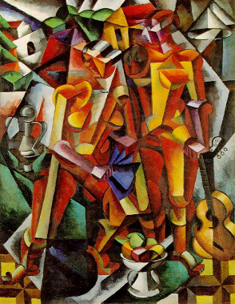 |  | Key Questions –  - How does it make you feel?  - How do you think the artist was feeling when they were creating the piece of artwork?  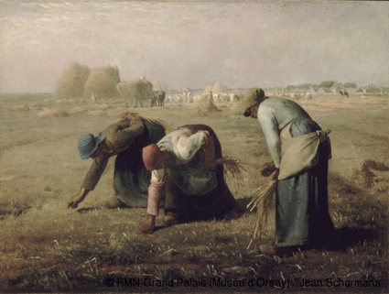
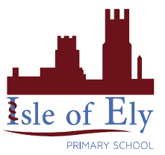
Knowledge Organiser
Summer Term 1
Art – Language of Art: The Content, Process, Form and Mood Model
Vocabulary
Content | The meaning derived from the art work, exploration of the meaning.
Form | To comment on how artwork is arranged and what colours and lines the artist has chosen to use.
Line | A line is a mark made on a surface that joins different points, it can be any length, shape or size.
Process | The process is how a piece of artwork was made.
Mood | The mood is how a piece of artwork makes me and others feel.
Colour | Colour is an element consisting of hues, of which there are three properties: hue, chroma or intensity, and value.

