Prime Ministers |  | 10 Downing Street
The Prime Minister of the United Kingdom is the head of the government for the UK.  The first Prime Minister was Robert Walpole.  The Prime Minister now is Boris Johnson.  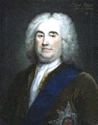  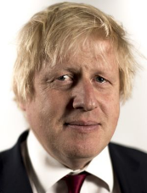  Can you name any others? |  | 10 Downing Street is the official home of the two most senior Government ministers  Downing Street is in London, close to Buckingham Palace.  It is only a few minutes’ walk from the Houses of Parliament.  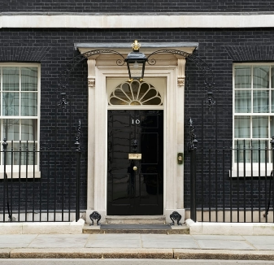
Buckingham Palace |  | The Houses of Parliament
Buckingham Palace has been the London home of the British king or queen since 1837.  The Royal Family live in the palace for some of the year, but it is also used for important events, meetings, and receptions  .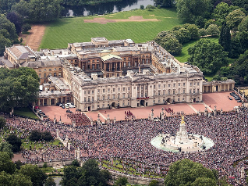 |  | Britain’s Parliament consists of two houses:  These are nobles or people born into the upper classes. They inherited their seats in the house.  House of Commons –  These people are elected by the public. There is an election at least once every five years. The Prime Minister is part of this.  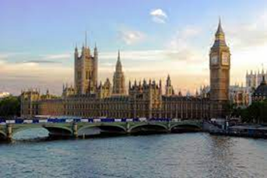
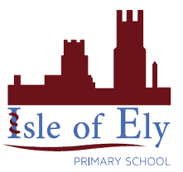
Knowledge Organiser
Summer Term 1
History – Prime Ministers and British Symbols
Vocabulary
Prime Minister | The head of an elected government
Government | The group of people with the authority to govern a country
Monarchy | A form of government with a monarch at the head
Cabinet | A team of 20 or so most senior ministers in the Government, chosen by the Prime Minister to lead specific areas like health and education.
Residence | The official home of a government minister or other public or official figure.
Chancellor of the Exchequer | The chief finance minister of the United Kingdom, who prepares the nations annual budgets.
Politician | A person who is professionally involved in politics.

