Musical activities |  | Listening
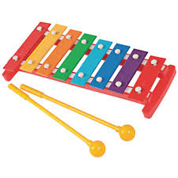  E  G  C |  | 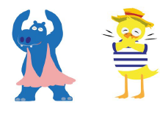  Copy and clap the rhythm  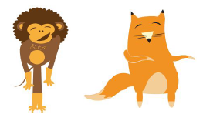  Clap the rhythm of your name  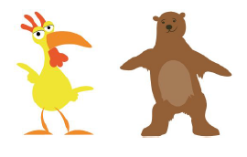  Find the pulse as you listen to music  Make up your own rhythms
Songs to Discuss and Appraise
Your Imagination

Supercalifragilisticexpialidocious

Pure Imagination

Daydream Believer

Rainbow Connection

A Whole New World
Knowledge Organiser
Summer Term 1
Music – Your Imagination

Vocabulary
Imagination | the ability of the mind to be creative or resourceful
Appraise | assess a performance
Pulse | the regular heartbeat of the music – its steady beat
Rhythm | long or short sounds or patterns that happen over the pulse
Glockenspiel | a percussion instrument composed of a set of tuned keys arranged in the fashion of the keyboard of a piano
Notes | a single tone of definite pitch made by a musical instrument or the human voice
Improvisation | Making up, and playing, a tune on the spot

