Questions we can ask… |  | Paintings of Children
What has been painted?  Who has been painted?  Where was it painted?  When was it painted?  Why was it painted? |  | 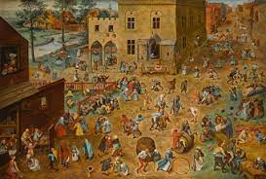  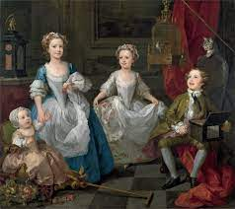  The Graham Children by Hogarth  Children Playing by Bruegel  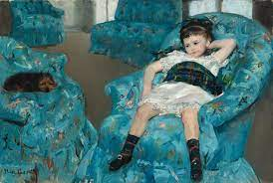  Little Girl in a Blue Chair by Mary Cassatt
Cubism
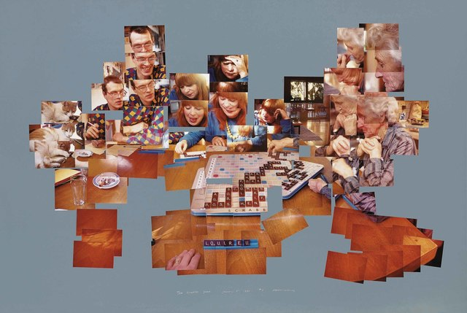
The Scrabble Game by David Hockney is painted in a cubist style.

The whole game is shown in one picture - as if we see it all at once.
Knowledge Organiser
Summer Term 2
Art – Discussing and creating artwork using line and colour

Vocabulary
Artist | A person who makes a work of art.
Luxury | When something is very comfortable and may be expensive.
Wealth | To have lots of money or things.
Message | An important piece of information that someone wants to share. This could be shown by a picture.
Past | A time that happened before now.
Pose | To put your body into a position so that someone can take a picture of you or draw you.
Cubism | A way of painting and drawing where artists show more than one view of something in the same picture, like looking at many sides of a cube at once.

