Spreadsheets |  | Planning and investigation
A spreadsheet is a computer program used for storing information.  A cell is an individual section of a spreadsheet grid.  Rows are the name for cells which go from left to right  Columns are the name for cells which go from the top to the bottom  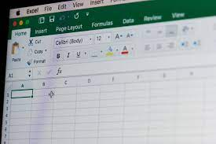 |  | Forwards, backwards, left and right are directions.  An icon or character which can be moved on a screen is called a sprite.  We can use direction keys to control a sprite.  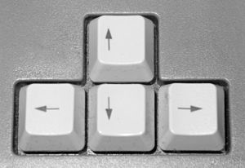
Spreadsheet Tools |  | Key Questions
Clip art is a function which allows you to create your own image.  The move cell tool allows you to move cells around your spreadsheet.  The lock cell tool stops a cell from being moved around the spreadsheet. 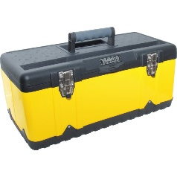 |  | • What is a spreadsheet?  • What is a cell?  • What is a row?  • What is a column?  • What does the image tool do?  • What is clipart?  • What does the move cell tool do?  • What does the lock cell tool do?
Knowledge Organiser
Summer Term 2
Computing – Data and Spreadsheets
Vocabulary
Spreadsheet | An electronic document in which data is arranged in the rows and columns and used in calculations.
Rows | Cells going across.
Columns | Cells going down.
Cells | A cell is a specific locations within a spreadsheet and is defined by the intersection of a row and column.
Image | A representation of a thing.
Toolbox | A set of software tools which can be accessed from a single menu.
Clipart | Simple pictures and symbols made available for computer users to add to their documents.

