How do wheels move? |  | Designing a vehicle
●Wheels allow vehicles to move  ●Mechanisms make a toy or vehicle roll forwards (axle, wheel and axle holder)  ●In order for a wheel to move it must be attached to an axle  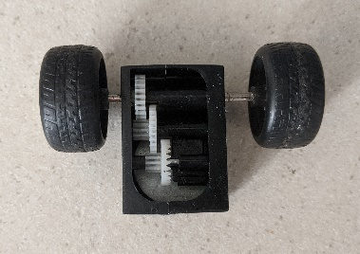 |  | Key questions to think about for your design:  How does a wheel work?  What do we need to make sure to guarantee our vehicles move?  What else do we need to consider for our vehicles?  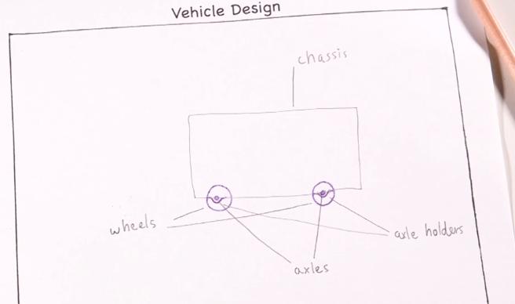
Fixing Broken Wheels |  | Wacky Races
How do we know why it is not working?  We looks for the following –  - Are the wheels prevented from turning  - Has the wheel got an axle  - Is the wheel circular  - Is the axle holder attached to the body of the vehicle  Now what can you do to fix it? |  | Let’s see how well these veichles turned out!  Did you make a moving vehicle that worked?  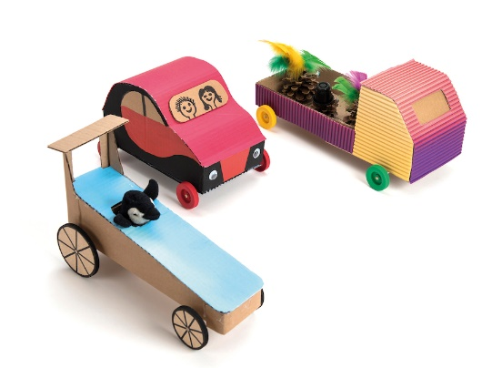
Knowledge Organiser
Summer Term 2
DT – Mechanisms: Wheels and Axles
Vocabulary
Axle | A rod or spindle passing through the center of a wheel.
Diagram | A simplified drawing showing the appearance, structure or workings of something.
Mechanism | A system of parts working together in a machine.
Wheel | A circular object that revolves on an axel and moves easily over the ground.
Axel Holder | The component through which the axle fits and rotates.
Equipment | The items needed to create something.
Chassis | The base frame of a car or wheeled vehicle.
Dowel | A peg used for holding together components of a structure.

