The Seven Continents
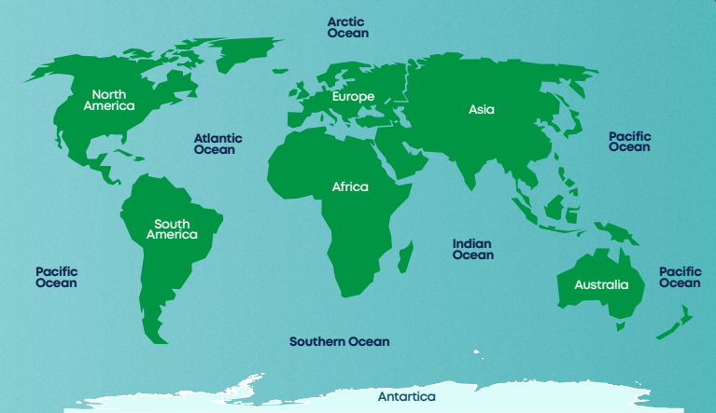

Physical Features |  | Human Features
Physical features of Earth’s  continents include:  Rainforest  Grassland  Savannah  Jungle  Desert |  | Human features of Earth’s  continents include:  The Great Wall of China  Statue of Liberty  Panama Canal  Sydney Opera House  Golden Gate Bridge
Knowledge Organiser
Summer Term 2
Geography – Seven Continents

Vocabulary
Earth | The planet we live on.
Continent | One of the world’s seven areas of land.
Ocean | A very large area of water.
Globe | A model of our earth showing the continents and oceans.
North Pole | A very cold place at the ‘top’ of the Earth.
South Pole | A very cold place at the ‘bottom’ of the Earth.
Equator | An imaginary line around the middle of the Earth.
Climate | The weather in a place over a long period of time.
Border | A line separating two countries.
Tilt | A sloping position.
Orbit | The curved path planets take around the Sun.

