Christian Stories |  | Christian Stories
The Miracles of Jesus  Christians believe that during Jesus’ time on Earth he performed many amazing miracles and this was because he wanted to share that he was the son of God.  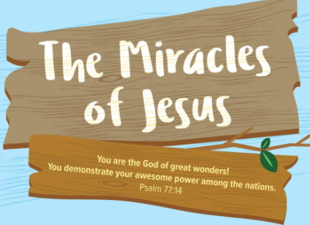  Jonah and the Big Fish  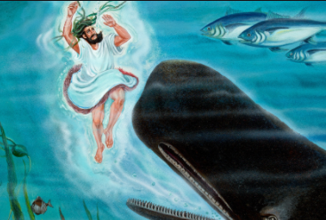  God told Jonah to go to Ninevah, but Jonah ignored God’s message and ran to sea. Whilst Jonah was at sea God sent a storm, the other people on the boat threw Jonah in to the mouth of a huge fish. Jonah said sorry and the fish spat him out. The next time God told Jonah to go to Ninevah he went. |  | 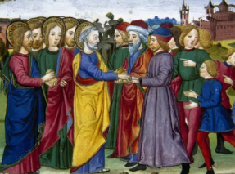  The Feeding of the 500  Jesus was sitting and chatting to his disciples when a huge crowd appeared, they were all very hungry. They saw a boy with 5 loaves of bread and 2 small fish. Jesus gave thanks to God and the bread and fish never ran out.  David and Goliath  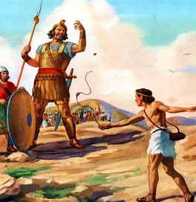  David was a shepherd boy, his people were at war. The Israelites and the Philistines were enemies, they had a man named Goliath who said choose a man to fight me and if I win you will be our slaves and vice versa. David agreed to fight Goliath and won.  Daniel and the Lions Den  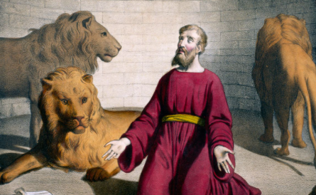  King Darius became King and put Daniel in charge of the governors. Daniel prayed to God every day. The governors were jealous of Daniel and so they created a law which meant no one was able to pray, if they did they would be thrown in to a lion’s den. Daniel continued to pray and was thrown in to the lion’s den, but God protected him.
Knowledge Organiser
Summer Term 2
RE - CHRISTIANITY: STORIES AND THEIR MEANINGS
Vocabulary
Stories | The Bible is full of stories, many of them have a purpose behind them.
Morals | Christian’s morals don’t change over time. They are consistent from generation to generation since their foundation is found in God’s Word, the Bible.
Disciples | A personal follower of Christ during his life.
Jesus | Jesus is the religious leader revered in Christianity, one of the world's major religions.
Morals
Here is a sampling of morals that are presented in the Word of God:

- Generosity, Courage, Love, Respect, Hope and Peace

