A pet needs…. |  | Describing Animals
Food  Water  Shelter  Space  Medicine  Love |  | 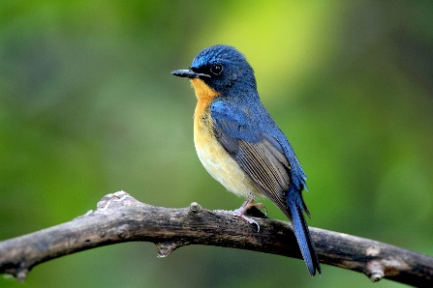  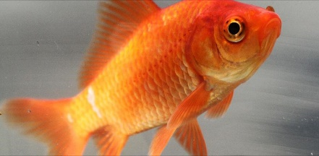  gills  fin  scales  wings  feathers  beak  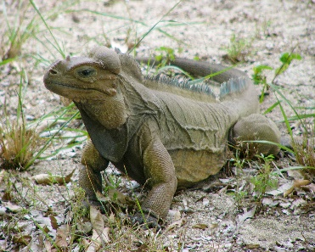  dry, scaly skin
Grouping Animals
Animals can be grouped by their features e.g.
Reptile, Mammal, Amphibian,
Bird or Fish

Animals can also be grouped by
what they eat e.g.
Omnivore, Herbivore or Carnivore
Knowledge Organiser
Summer Term 2
Science – Animals and their Needs
claws
Vocabulary
Animal | A living thing that moves and breathes.
Mammal | A warm-bloodied animal, with a backbone, that has hair or fur. Most mammals live on land.
Amphibian | A cold-bloodied animal that can live in water and on land.
Reptile | A cold-bloodied animal that breathes air and has dry, scaly skin.
Bird | A warm-bloodied animal that has feathers, a beak, wings and can usually fly.
Fish | An animal with a backbone, but no arms and legs that lives completely underwater, has scales and gills.
Pet | An animal kept and cared for in a person’s home.
Omnivore | An animal that eats both other animals and plants.
Carnivore | An animal that eats other animals.
Herbivore | An animal that eats plants.

