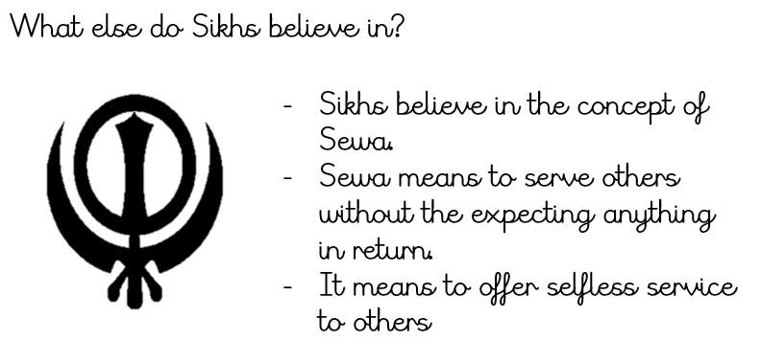
Knowledge Organiser
Year 2 - Spring Term B
RE – Sikhism - Khalsa
Vocabulary
Amrit | Amrit is a mixture of sugar and water that has been stirred with a double-edged sword. It is used in the Amrit Ceremony
Adi Granth | Is the holy scripture or book in Sikhism
Five K’s | Items traditionally worn or carried by Sikhs , each possessing a symbolic importance
Gudwara | The Sikh holy place of worship
Guru | A guru is a spiritual leader or teacher
Khalsa | a community of Sikhs who have committed themselves to their religion and who have agreed to follow certain traditions and rules.
Sewa | The concept of ‘selfless service’ to others.
Sikhism | A religion started over 500 years ago in Asia.

