 Knowledge Organiser

Year 2 - Spring Term A

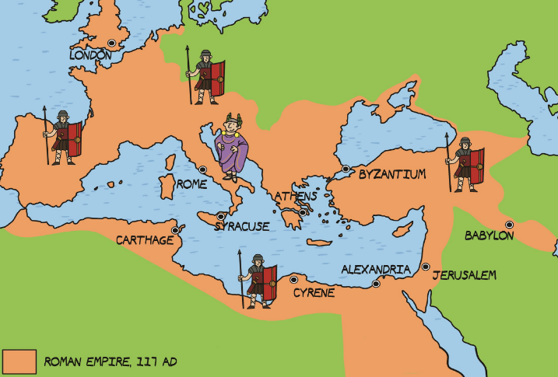 **History – Roman Britain: The Rise and Fall**

|  |  |
| --- | --- |
| **Key Vocabulary** | **Definition** |
| empire | A group of states or countries ruled over by a single person |
| legion | A large group of soldiers who form one section of an army. |
| cavalry | Soldiers who fought on horseback. |
| invasion | The entering or taking over of a place, by force |
| rebellion | When a group of people are angry about something, usually something done by the people in power, and rise up and fight them |
| emperor | A man who rules an empire |
| defeat | To win against someone in a fight, war, or competition |
| aqueduct | Bridge-like system built to move water from one location to another |
| centurion | Soldier in the Roman army responsible for the command of one hundred men. |

|  |  |
| --- | --- |
| **Important People** | |
| **Boudicca** | Led a rebellion against the Romans |
| **Julius Caesar** | Tried to invade Britain but was unsuccessful |
| **Emperor Claudius** | Successfully invaded Britain and made it part of the Roman Empire |

