Knowledge Organiser
Year 2 - Spring Term B
Vocabulary
Binary | A simple way of representing two data points, often shown as a 0 or a 1.
Binary Tree | A simple way of sorting information into two categories.
Collate | Collect and combine (texts, information, or data).
Column | Vertical reference points for the cells in a spreadsheet.
Data | Facts and statistics collected together that can provide information.
Database | A computerised system that makes it easy to search, select and store information.
Pictogram | A diagram that uses pictures to represent data.
Row | Horizontal reference points for the cells in a spreadsheet.
Spreadsheet | A computer program that represents information in a grid of rows and columns.
Computing – Data & Spreadsheets

Binary Tree

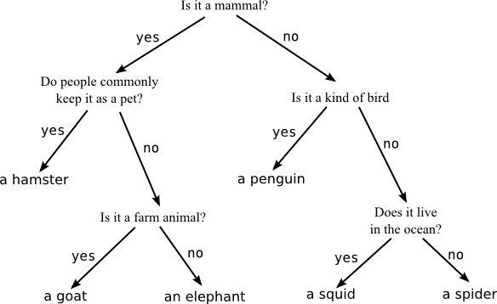

What does this diagram tell you?

