Knowledge Organiser
Year 2 - Spring Term B
Vocabulary
Band | A band is a small group of musicians who play popular music
Bass | A bass musical instrument produces tones in the low-pitched range
Electric Guitar | An electrical guitar is one which uses is supported by an electrical system.
Pulse | Steady beat of the music.
Rhythms | Rhythm is what makes music move and flow. Rhythm is made up of sounds and silences
Queen | Queen are a famous American band known for a number of songs including ‘We will rock you’.
Status Quo | Status Quo are a famous British band known for a number of songs including ‘ Rockin’ All Over The World.
The Beatles | The Beatles are a famous British band known for a number of songs including ‘ She Loves You’.
Music – I Wanna Play in a Band

Listen
The following songs are going to be key music in this unit, find the music and see if you can identify the pulse and the rhythm:
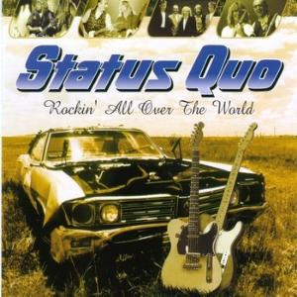
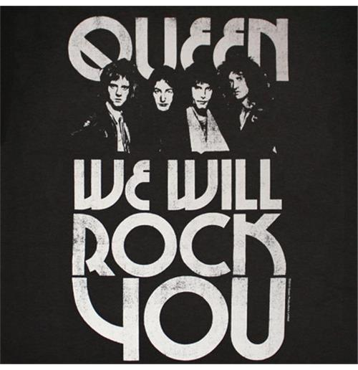

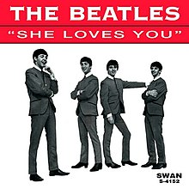
Key to rock bands are the instruments that they use, the above bands have some of the best musicians in the world.

