Knowledge Organiser
Year 2 - Spring Term B
Vocabulary
Absorb | To take in or soak up.
Bulb | Bulbs are simply underground masses of food storage from which plants grow
Dispersal | Spreading things out over an area, seeds do this to help to reproduce.
Flowers | The part of a plant that bears the seed.
Nutrients | Goodness required for life and growth. Plants absorb nutrients from the soil.
Plant | A living thing that grows in the earth and has roots, leaves and a stem e.g. grass, trees, bushes, flowering plants.
Pollination | The transfer of pollen from one part of a plant to another.
Root | The part of a plant that acts as an anchor, fixing the plant into the ground. Roots also absorb water to help the plant to grow.
Seed | A seed contains a miniature plant
Stem | The part of the plant that grows above the ground. The leaves and flowers grow from it. The stem is also used to transport water around the plant.
Science – Plants

Seeds can come in many different shapes and sizes

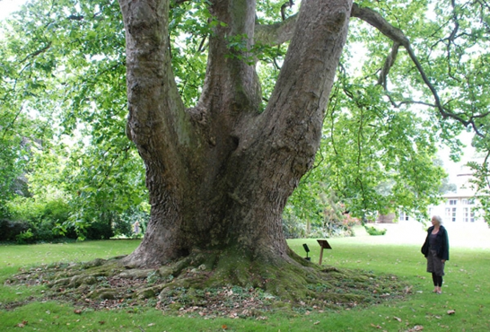

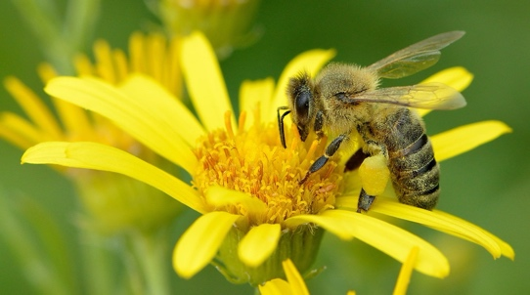
Many flowers rely on animals to help with pollination by moving pollen from one flower to another.

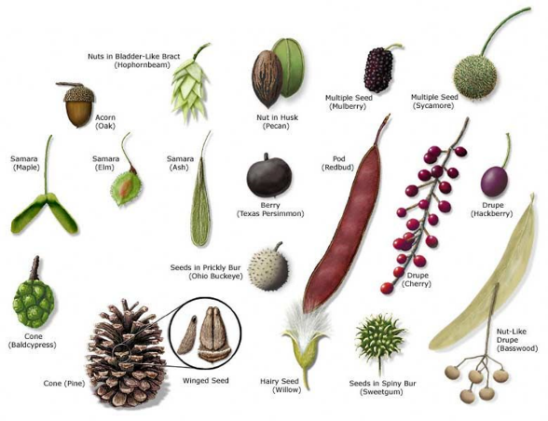

The oldest London Plane Tree in Britain can be found in Ely. It has a girth or over 9 metres.

