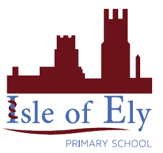
Knowledge Organiser
Year 2 – Summer B
RE – Important Celebrations
Vocabulary
Celebrations | A day, week or sometimes an entire month given to acknowledge and celebrate important people or moments.
Christmas | A Christian holiday in which Jesus’ birth is celebrated
Diwali | Diwali is a festival of lights and one of the major festivals celebrated by Hindus, Jains and Sikhs.
Eid-al-Fitr | A religious holiday celebrated by Muslims worldwide that marks the end of the month-long dawn-to-sunset fasting of Ramadan
Hanukkah | Hanukkah is a Jewish festival reaffirming the principles of Judaism.
Lakshmi | Lakshmi is one of the principal goddesses in Hinduism. She is the goddess of wealth, fortune, love, beauty, joy and prosperity
Menorah | A special Jewish candle used during Hanukkah
Ramadan | Ramadan is the ninth month of the Islamic calendar, during this time Muslims fast, pray and reflect

What do religious celebrations have in common?
These celebrations have some things in common:
- They give gifts to one another
- They retell old stories
- Eating and drinking together
- People coming together

Important Celebrations
Can you name these religious celebrations?
