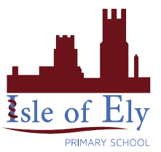
Knowledge Organiser
Year 2 - Summer Term B
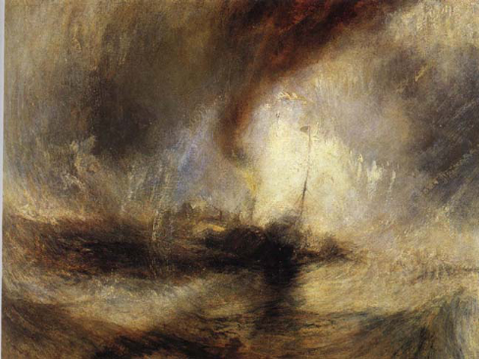
Art – Types of Painting: Landscapes and Seascapes
Form
What colours have been used?
Content
What can you see?
Mood
How does it make you feel?
Key Vocabulary | Definition
landscape | A painting or drawing of a large area of the natural world, for example mountains or fields.
seascape | A type of landscape painting which is of the sea.
method | A way of doing something, for example the steps for painting a picture.
sketch | A rough drawing or painting, possibly to be looked at to be able to complete a finished drawing or painting.
brushstroke | The mark made by a paintbrush.

Turner (1842) Snowstorm

We will look in detail at the seascapes created by Turner. We will discuss his work using Rod Taylor’s Content, Form, Process, Mood Model. We will then use this as inspiration to create our own seascapes. We will recall our previous knowledge of colour through this unit of work.
Process
How do you think the artist created this?

