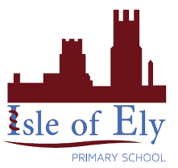
Knowledge Organiser
Year 2 – Summer Term B
Vocabulary
Clef | A clef is the symbol at the start that tells you whether the notes are low or high
Bars | An amount of time which represents a specific number of beats
Bar Lines | Bar lines are used to separate one bar from another
Duration | The term for how many beats a note is worth.
Minim note | A minim note is worth 2 counts, a minim rest is worth 2 counts of silence
Pulse | The heartbeat or steady beat of a song/piece of music.
Stave | A stave is the 5 lines that notes are written on
Tempo | Tempo is the musical word to describe how fast or slow the music goes
Time Signature | The numbers at the start of the music that shows you how the pulse is grouped
Music – Reflect, Rewind and Replay

Clefs show whether the notes are high or low
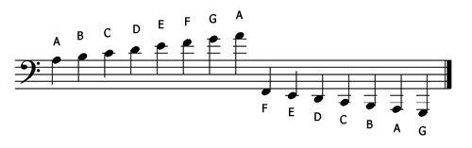
Bar lines are used to spate one bar from another
Crochets is used to show one count
A minim note is worth two counts and a minim rest is worth two rests
Key Songs
Peer Gynt | Suite number one
Johann Sebastian Bach | Brandenburg Concertos
Frank Sinatra | Fly me to the Moon
Queen | We Will Rock You
Bela Bartok | From the diary of a fly
Marcia  Griffiths | Feel like jumping

