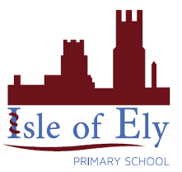
Knowledge Organiser
Presenting stories or texts in different ways
Year 2 - Summer Term B
How could you present your favourite story using a digital device?
Vocabulary
Audience | The people for whom a product or service is made for.
Animation | A process by which we see still pictures appear to move.
E-book | An e-book is an electronic book and can have advantages which a paper book does not have including animation and sound. This is one way we can represent a story or text.
Fact File | A fact file is a collection of information about a particular subject or product. This is one way we can represent a story or text.
Mind map | A tool for organizing and representing knowledge. They form a web of ideas which are all interconnected. This is one way we can represent a story or text.
Quiz | An A test of knowledge, especially as a competition between individuals or teams as a form of entertainment.
Representation | A representation is how something is shown or displayed. The same product can be displayed in a number of different ways.
Computing – Presenting Ideas

Mind map

Quiz

What other ways could you present this story?
What are the advantages and disadvantages of each?
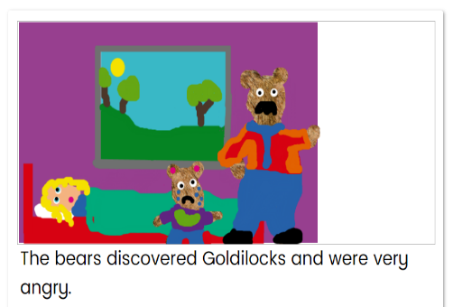
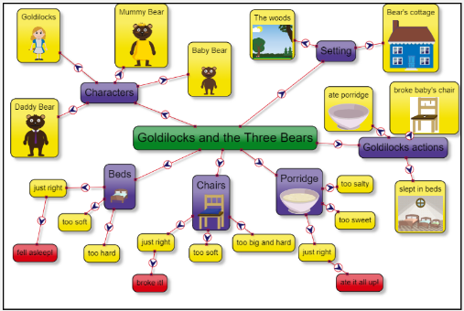

E-book
