Key People
King Cnut (Canute) | A Viking king who ruled Denmark, England and Norway
Edward the Confessor | An English king who built the original Westminster Abbey
Alfred the Great | Ruled the kingdom of Wessex and fought back against the Vikings in Britain
Harold Godwinson | A nobleman from Wessex and the last crowned Anglo-Saxon king of England
Harald Hardrada | King of Norway from 1046 to 1066
William the Conqueror | Defeated Harold Godwinson at the Battle of Hastings, 1066 and became King of England
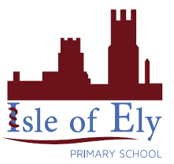
Knowledge Organiser
Year 2 - Summer Term B
History – Anglo Saxons to the Normans
Key Vocabulary | Definition
Anglo-Saxon | A mix of people from Germany, Denmark and the Netherlands who came to live in England during the 5th Century. The three biggest tribes were the Angles, the Saxons and the Jutes.
Bayeux Tapestry | An embroidered cloth created to show the story of the Battle of Hastings.
Invasion | To enter a country or place by force with the intent of taking over.
Kingdom | A country or place ruled by a King or Queen.
Migration | Where people move from one place to live in another place.
Settlement | A place where people live, and sometimes work.
Raid | An unexpected attack where an enemy comes to steal and/or destroy.
The Battle of Hastings | A battle between William the Duke of Normandy and King Harold harada to decide who would be king of England.
Trade | Buying and selling goods or services.
Viking | People of Scandinavian origin who travelled by sea and raided, invaded and settled in Europe from the 8th century.

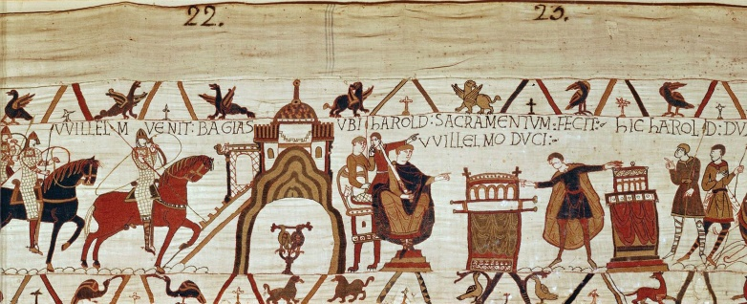
A section of the Bayeux Tapestry.

Key dates
