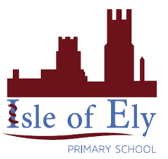
Knowledge Organiser
Year 2 – Summer B
Vocabulary
Solar System | The Sun, the eight planets, their moons, and other smaller objects together make our Solar System.
Planets | The planets in our solar system are Mercury, Venus, Earth, Mars, Jupiter, Saturn, Uranus and Neptune. Pluto is a dwarf planet.
Orbit | The path of an object around another, orbits usually follow a circular shaped path. The Earth orbits the Sun.
Rotate | Turning around an axis. The Earth rotates as it orbits the Sun.
Moon | Our moon orbits the Earth, it is made of rock and metal. Some, but not all, planets have moons. Some planets have more than one moon.
Reflect | When light bounces from an object. Light from the sun reflects on our moon, making it look like it is shining.
Waxing | When we can see more of the moon each night.
Waning | When we can see less of the moon each night.
Science – Astronomy

It takes 29 days for the Moon to orbit the Earth. When the moon appears to get bigger, we say it is waxing, and when it appears to be getting smaller, it is waning. We call these different shapes the phases of the moon.

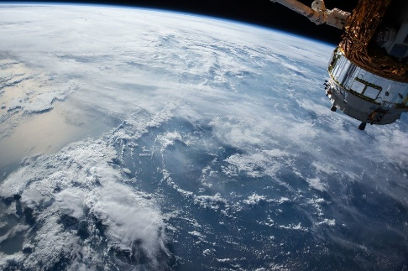

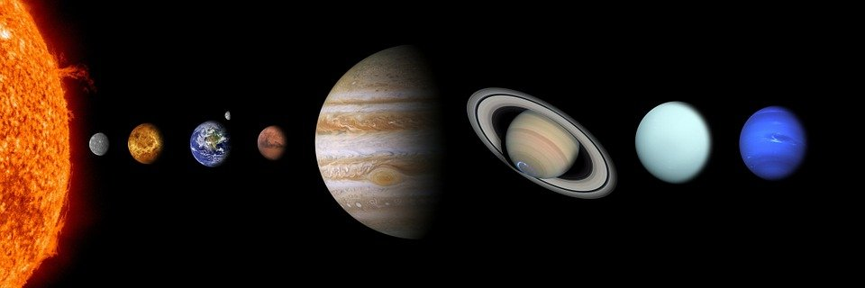

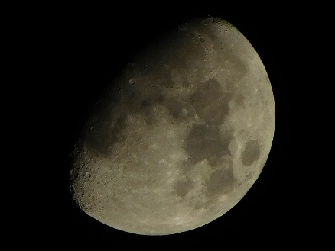
We will use the mnemonic “My Very Easy Method Just Set Up Names” to help us remember the order of the planets.

The International Space Station orbits Earth and allows scientists to find out more about space.

