What are the 5 different senses? |  | My Skeleton
Touch  Sight  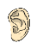Hearing  Smell  Taste |  | 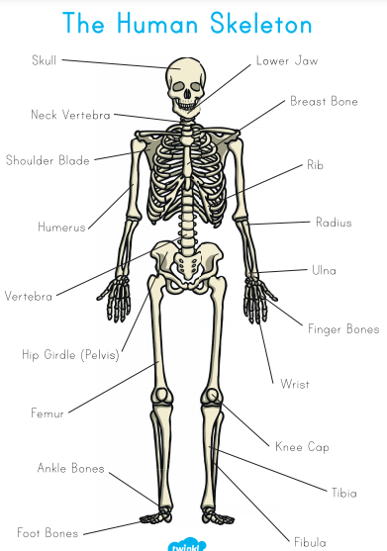  This is the internal framework of our body.
Which part of the body is associated with each sense?
Touch –> hands and feet

Sight –> eyes

Hearing –> ears

Smell –> nose

Taste –> mouth and tongue

Knowledge Organiser
Autumn Term 1
Science – Body Parts and Senses
Vocabulary
senses | Our senses are what help us to understand and interact with the world we live in.
touch | Your skin gives you a sense of touch. So even when you are not looking you can tell if something is soft or rough or cold or hot.
sight | Your eyes are especially made to see what is around you. They make sure you can see things that are very close and far away. They need plenty of light to do it.
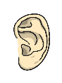  hearing | Your ears are especially designed to hear what is going on around you. Even when you are hearing lots of different things at once, your brain is very good at recognising the different sounds.
smell | Your nose is designed to detect smells. It can tell the difference between nice smells and nasty ones
taste | Your mouth and tongue give you your sense of taste so you can tell what tastes bitter to what is sweet.
skeleton | The internal framework of our body.

