Humanism – What is it?
- Humanism is an approach to life based on reason and common humanity.  - Humanism recognises that moral values are found on human nature and experience alone.  - Humanists believe the pursuit of happiness is one of the most important aspects of human life and being kind to others creates happiness. | - The happy human is the international symbol for humanism.
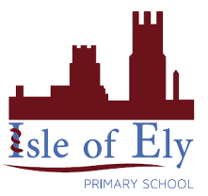
Knowledge Organiser
Year 3 - Autumn Term B
Vocabulary
Agnostic | Belief that the existence of god is unknown.
Atheist | The belief that there is no God.
Natural Selection | ‘Survival of the fittest’. The best organisms survive evolution.
The Big Bang theory | The world leading explanation for how the universe began
The Golden Rule | The belief that we should treat others how we wish to be treated
Celebrant | Someone who performs important ceremonies, such as weddings
Happy Human | The international symbol for Humanism
Human Rights | The basic rights and freedoms all people have from birth until death.
Religious Education- Humanism
Key Facts
- Humanists believe there are no supernatural beings.
- The material universe is the only thing that exists
- Science provides the only reasonable source of knowledge about the universe
- There is no afterlife
- Humans can live ethical and fulfilling lives without religious beliefs.
- Human beings derive their moral code from the lessons of history, personal experience and thought.

