Knowledge Organiser
Year 3 - Autumn Term B
Vocabulary
bank | The riverbank is the land at the side of the river.
basin | An area of land drained by a river and its tributaries.
bed | The riverbed is the bottom of the river. It can be made of sand, rocks or mud depending on the river.
current | The strength and speed of the river.
confluence | The junction of two rivers (where two rivers meet).
delta | A wide muddy or sandy area where some rivers meet the sea. The river slows down and drops the sediment it was carrying.
estuary | Where a river meets the sea – the tidal mouth. Estuaries are usually wide and flat.
floodplain | The flat area around a river that often gets flooded when the level of water in the river is high.
meander | A bend in the river.
mouth | The end of the river where it flows into the sea, another river or a lake.
source | The start of the river.
tributary | A smaller river or stream that joins a larger river.
The Water Cycle | 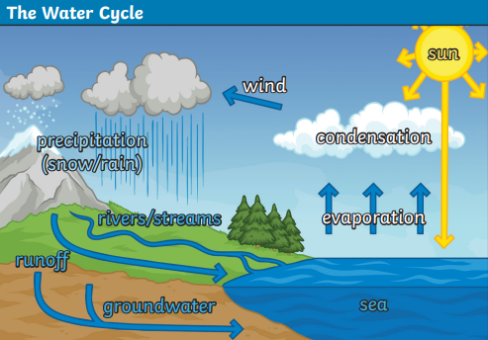
The water cycle is the continuous journey of water from oceans and lakes, to clouds, to rain, to streams, to rivers and back into the ocean again.

Evaporation  When a liquid is heated and changes into a gas or water vapour. | Condensation  When a gas cools and changes into a liquid. | Precipitation  Rain, hail, sleet or snow.
Geography – Rivers and Basins
Rivers
Rivers run through every continent of the world except Antarctica.  Europe - Thames, Trent, Severn, Volga and Rhine  Asia - Ganges and Yangtze  Africa - Nile and Congo  South America - Amazon and Panama North America - Mississippi and Rio Grande  Australasia - Murray-Darling | 