Knowledge Organiser
Year 3 – Spring Term B
Geography – Settlements
Key Vocabulary | Definition
Settlements | A settlement is a place where people live.
Urban | An area where a large number of people live near to each other. Urban areas have lots of buildings and roads.
Rural | An area located outside of towns and cities, sometimes called the countryside.
suburban | An area on the edges of towns and cities where people live.
Population | The number of people living in an area
Conurbation | An urban area that has developed when the suburban areas of several towns or cities merged.

Urban Area | Rural Area
 | 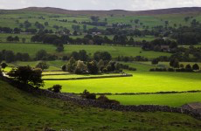

Types of Settlements:
Hamlet | 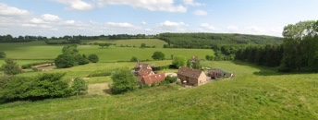 | A small settlement with a very small number of homes and no services.
Village | 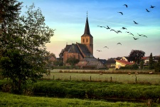 | A group of houses in the countryside, sometimes with a church and small shop.
Town | 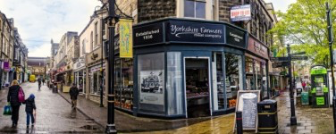 | A place where there are lots of houses and shops. A town may have a local council that makes decisions for the people who live there.
City | 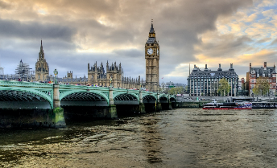 | A city is a large urban area where lots of people live close to each other. There are often lots of shops and services in a city

