The three diets of animals
Herbivore | Carnivore | Omnivore
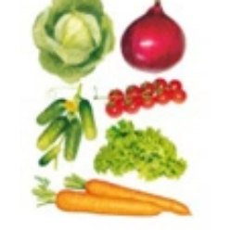 | 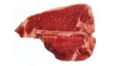 | 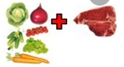
Knowledge Organiser
What is a balanced diet?
The human body needs a balanced diet to work properly. Good health involves drinking enough water and eating the right amount of foods from the different food groups.

Carbohydrates | They give us energy. They are found in foods such as bread, potatoes and pasta.
Proteins | These help our bodies to repair themselves. They are found in foods such as fish, meat, nuts, seeds, eggs and cheese.
Fats | These help store energy for our bodies. They are found in foods such as butter, cheese and fried foods.
Fibre | It is important for helping us digest our foods. It’s found in fruit and vegetables.
Year 3 - Autumn Term B
Vocabulary
Skeleton | The internal or external framework of bone, cartilage, or other rigid material supporting or containing the body of an animal or plant.
Femur | The thigh bone.
Humerus | The arm bone between your shoulder and your elbow.
Exoskeleton | The external skeleton that supports and protects an animal's body.
Contract | The activation of tension-generating sites within muscle fibers
Relax | The time in which a muscle returns to a resting position.
Muscle | A group of muscle tissues which contract together to produce a force
Joint | The connection made between bones in the body which link the skeletal system into a functional whole. They are constructed to allow for different degrees and types of movement.
Science – Animal bodies, including humans

