Key Vocabulary | Definition
Balkans | South of the Danube are the Balkan countries, along the Balkan Peninsula. These include Croatia, Albania, Bosnia-Herzegovina, Bulgaria and Kosovo
Baltic Countries | Countries located on the Baltic Sea Latvia, Lithuania, Estonia. This term sometimes includes Poland.
Cyrillic | An Alphabet they use in Russia, named after St. Cyril who translated the Bible.
Human Geography | The geographical study of people and their communities, cultures, economies, and interactions with the environment.
Physical Geography | The geographical study of processes and patterns in the natural environment like the atmosphere, hydrosphere, biosphere, and geosphere.
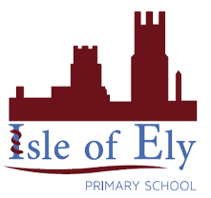
Knowledge Organiser
Year 3 – Summer Term 2
Geography- Eastern Europe
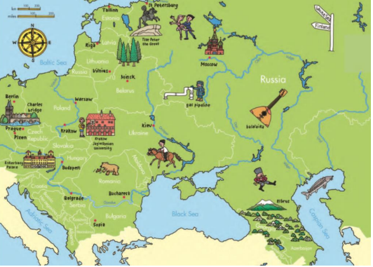
Important Seas:
Caspian Sea
Black Sea
Baltic Sea
Adriatic Sea

Russia
Language | Russian
Capital | Moscow
Population | 144,463,451
Currency | Russian ruble (₽) (RUB)
Flag | 