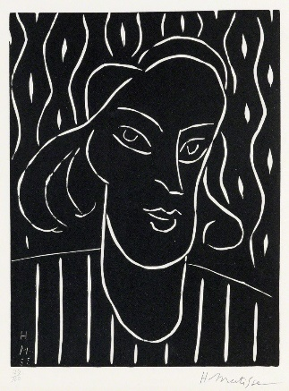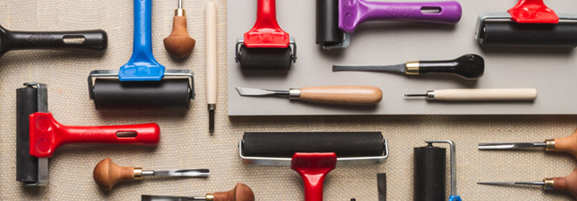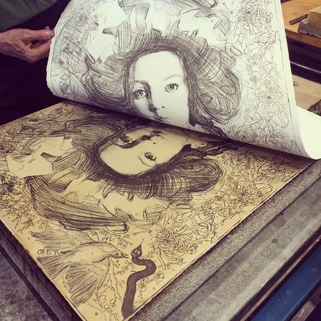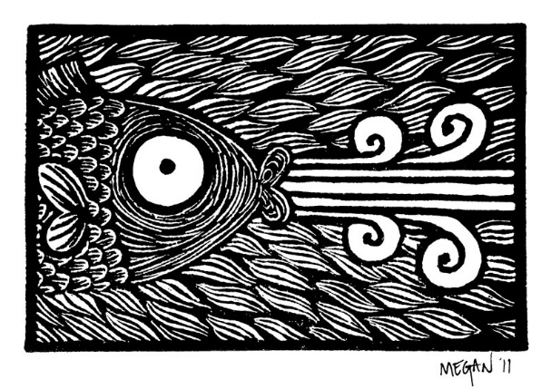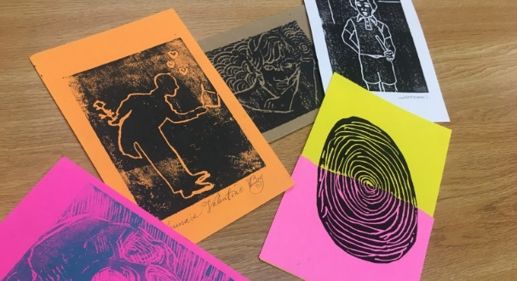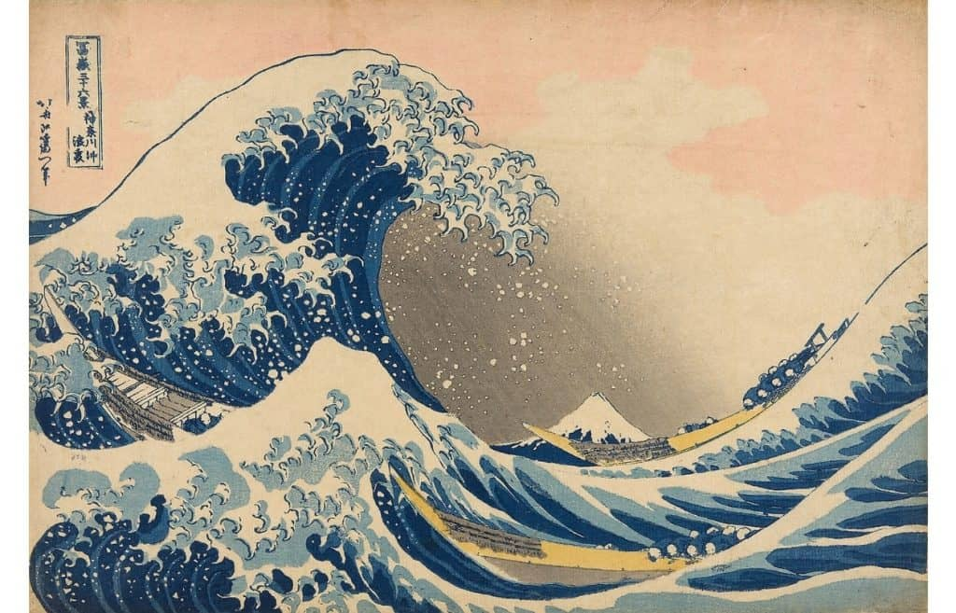

**Key Artists:**

William Morris

Pablo Picasso

Andy Warhol

Henri Matisse

**Key Vocabulary:**

Prints

Design

Print making

Roller and Ink

**Printing Skills:**

Monoprint Quick print Foam

Acetate Stencil Print

Intaglio Print Relief Print

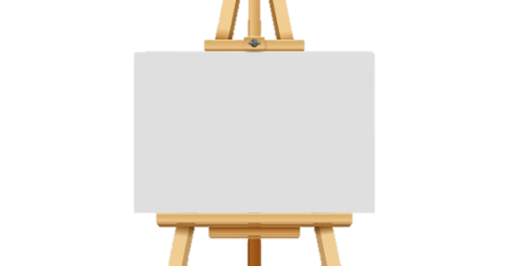

**Art Knowledge Organiser**

***Unit of Work:* Printing and Printmaking**

***Year Group:* 5 *Term:* Spring B**

Key figures: