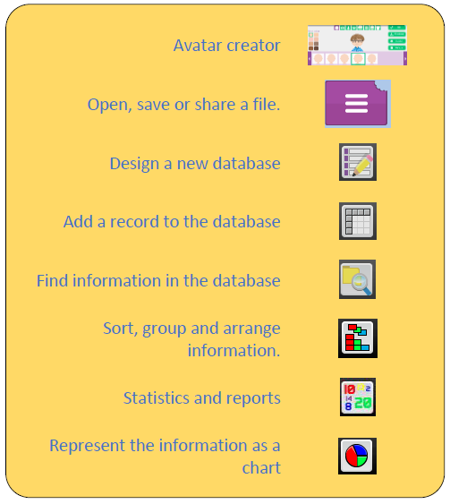



**Computing Knowledge Organiser**

***Unit of Work:* Databases**

***Year Group:* 5 *Term:* Spring B**

**What could we question?**

What is a database? Why is the collaborative feature important? In what ways can I sort information in a database?

**Key Vocabulary:**

**Avatar –** An icon or figure representing a person in a video game, Internet forum, etc.

**Binary tree (branching database) –** A way to sort information by dividing the information into groups based upon questions with yes or no answers.

**Charts –** Representing information in a pictorial form.

**Data –** Facts and statistics collected together for information.

**Database –** A set of data that can be held in a computer in a format that can be searched and sorted for information.

**Find -** Search for information in a database.

**Record –** A collection of data about one item entered into a database.

**Sort, Group and Arrange –** Different ways to sort information in a database to it is easy to read, understand and interpret.

**Statistics and reports –** To produce information about data in a database.

**Table –** Sorting information into rows and columns.

Key figures: