Key Vocabulary: | Definition:
Arid | Area of land or climate with little or no rain that is too dry or barren to support vegetation.
Continent | A large land mass of different countries. There are 7 continents in total.
Desert | Sand and stone with few plants.
Physical Geography | There are natural features of the Earth such as landforms and ecosystems.
Population | All the inhabitants in a particular place
Precipitation | Is rain, snow, sleet or hail that falls or condenses on the ground.
Semi-arid | Dry but has slightly more rain than an arid region.
Sahel | An eco-climate of transition between the Sahara and Savannah.
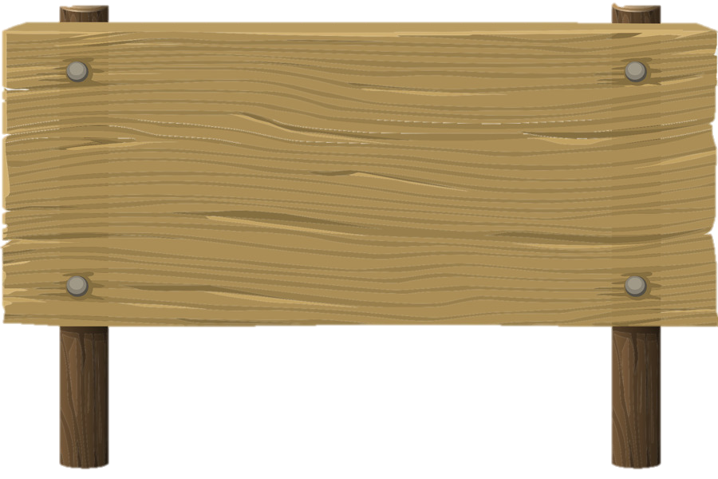
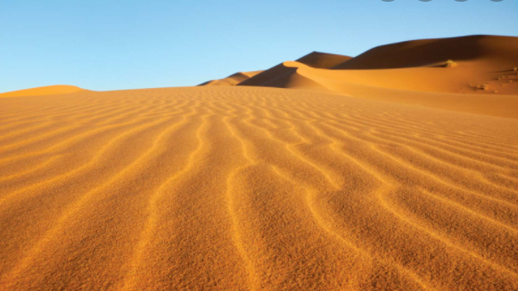
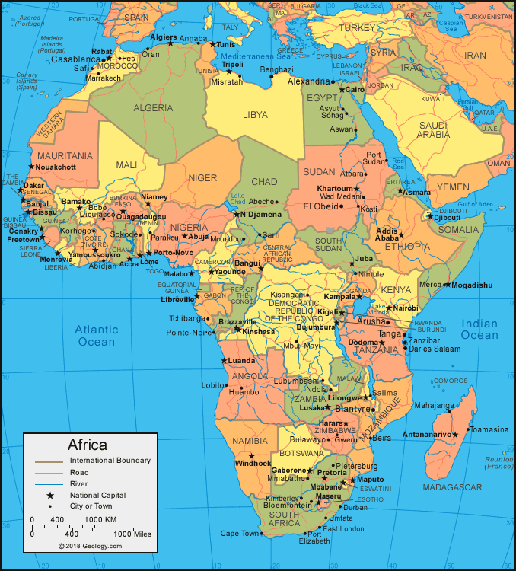
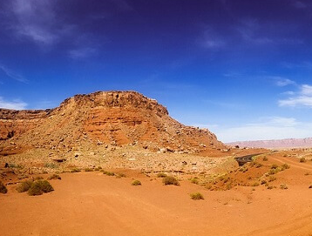
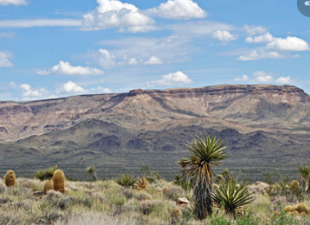
Geography Knowledge Organiser
Unit of Work: Africa – Physical Geography
Year Group: 5 Term: Spring B
Desert –
Sand and stone with few plants.
Arid –
Bold, rocky, and sandy surfaces. Little or no moisture.
Semi-Arid –
Steep climate, rainy and some moisture.
Key figures:

