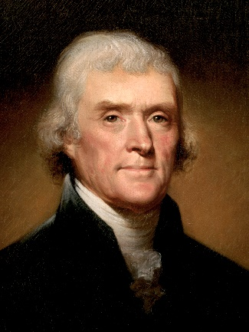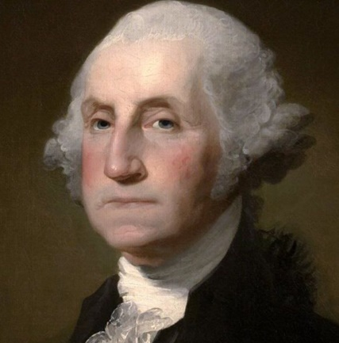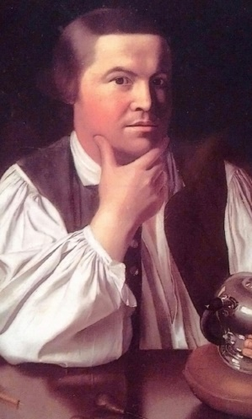



**History Knowledge Organiser**

***Unit of Work:* The American Revolution**

***Year Group:* 5 *Term:* Spring B**

**Key Vocabulary:**

**Colony** – A group of people from one country who build a settlement in another territory, or land.

**Taxation** – Ways that the government can collect money from its citizens to pay for things that the people need, like schools and roads.

**Representation** – To act for or on behalf of someone or for something.

**Liberty** – The power to do as one pleases or as you wish.

**Independence** - Not having to depend on anyone or anything else. It also means being strong and able to survive alone.

**Key Figures:**

. George III **–** Current Reigning Monarch, also governed America.

**. Thomas Jefferson –** Lawyer who drafted and wrote the declaration of independence.

**. George Washington –** Leader of the American rebels, later became Americas first President.

**. Paul Revere –** A hero of the American Revolution. He is most famous for riding his horse through the countryside near Boston to warn the colonists that the British were coming.

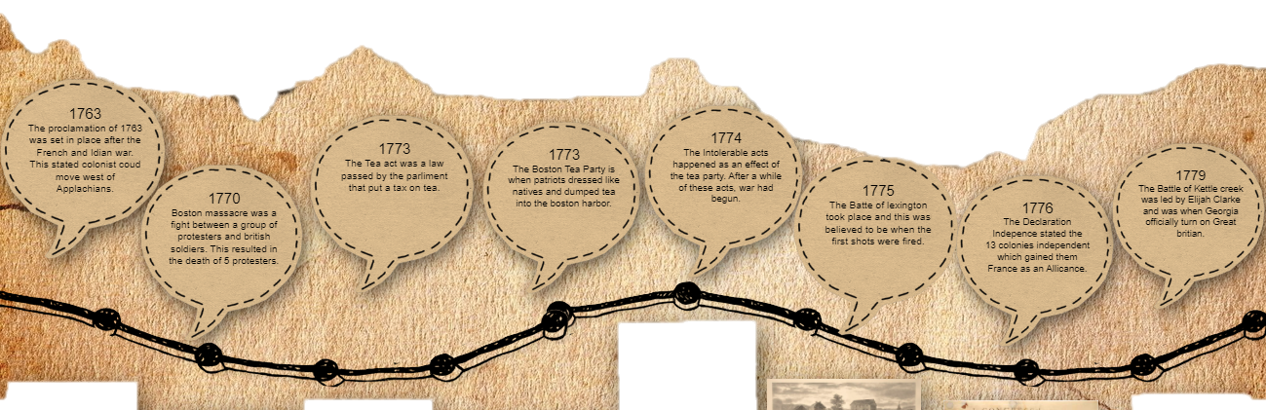

Key figures: