Key Vocabulary: | Definition:
Force | A push or a pull
Gravity | A force that pulls objects towards the centre of the earth
Friction | A force caused by two surfaces touching each other
Air Resistance | A kind of friction that slows objects down when they travel through air
Water Resistance | A kind of friction that slows objects down when they travel through water
Buoyancy | An object’s ability to float
Upthrust | A force that pushes objects up in water or air
Streamline | To shape an object in a way that reduces the effect of air resistance or water resistance.
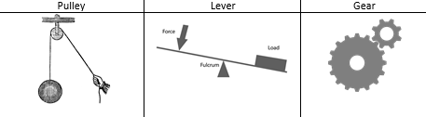
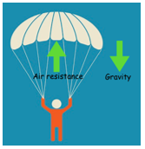
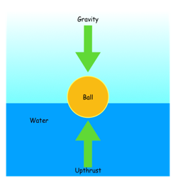
Science Knowledge Organiser
Unit of Work: Forces
Year Group: 5 Term: Spring B
Key figures:

