**RE Knowledge Organiser**

*Year Group:* **5** *Term:* **Summer A**

*Unit of Work:*

**Promotion of Peace**



**What could we question?**

What does peace mean? What is the difference between the two definitions of peace? What does peace mean to each religion? How have religions enabled peace? Which religions focus on inner peace? Which techniques do they use to achieve this?

Key figures:

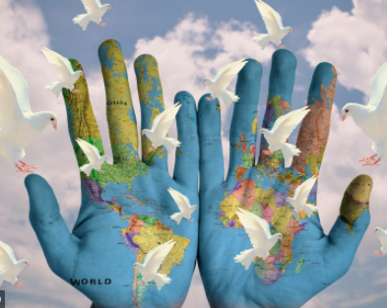

**Key Vocabulary:**

**Peace** – Freedom from disturbance: tranquillity.

A state or period in which there is no war or a war has ended.

**Cohesion** – The action or fact of forming a united whole.

**Community** – A group of people living in the same place or having a particular characteristic in common.

K**ey religions**

Hinduism

Buddhism

Christianity

Islam

Sikhism

Judaism



